Quiz - Week 7: Circuits
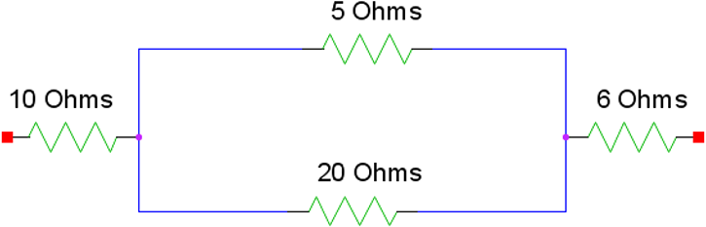
- Current is allowed to flow through the resistor network shown above, from left to right. If the potential difference between the left and right sides of the network is 10V, what is the current that flows through this network?
  - 20 A
  - 10 A
  - 2 A
  - 1 A
  - 0.5 A

- Two capacitors, with different capacatances of C1 and C2 are connected in parallel and allowed to fully charge. If C1 < C2, which of the following statements are true?
I. The voltage drop across C1 is greater than the voltage drop across C2
II. The charge stored in C1 is less than the charge stored in C2.
III The current flowing through C1 is greater than the current flowing through C2.
  - I only
  - II only
  - III only
  - I and II
  - I, II, and III

- A computer monitor runs on 120 Volts, and has an internal resistance of 100 W. What power that is used by the monitor is closest to -
  - 1.2 W
  - 12 W
  - 15 W
  - 120 W
  - 140 W

- A 5 Ohm resistor is connected to a 10 volt Battery. The resistor is then submerged in 2 kg of mineral oil (c ≈ 1700 J/kgºC). What is the temperature increase of the mineral oil if the resistor is left powered for 850 seconds?
  - 2 °C
  - 5 °C
  - 10 °C
  - 17 °C
  - 20 °C

- What do the three basic components (resistor, capacitor, inductor) of a circuit do?
Resistor Capacitor Inductor
  - Dissipates energy as heat Stores energy in an electric field. Stores energy in a gravitational field.
  - Stores energy in an electric field. Stores energy in a magnetic field. Dissipates energy as heat
  - Dissipates energy as heat Stores energy in a magnetic field. Stores energy in an electric field.
  - Stores energy in a magnetic field. Dissipates energy as heat Stores energy in an electric field.
  - Dissipates energy as heat Stores energy in an electric field. Stores energy in a magnetic field.

Questions 6-7 refer to the following diagram:
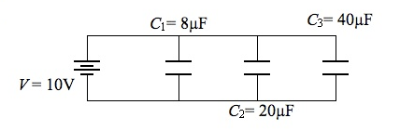
- Three capacitors are wired in parallel, as shown above. What is the equivalent capacitance of the circuit?
  - 5 mF
  - 6.8 mF
  - 12 mF
  - 68 mF
  - 6400 mF

- To measure the voltage of the capacitor C₃ a volt meter should be connected -
  - In series with C₃
  - In parallel with C₃
  - In series with the source, before C₃.
  - In series with the sourse, after C₃.
  - None of the above.

- The current and resistance of several light bulbs are listed below. Which lights would appear equally bright?
Light Bulb | Current (A) | Resistance (W)
1 | 1 | 25
2 | 2 | 16
3 | 3 | 9
4 | 4 | 4
5 | 5 | 1
        - Light 1 and Light 5
        - Light 2 and Light 4
        - Light 3 and Light 4

  - I only
  - II only
  - I and II only
  - II and III only
  - I, II, and III

Questions 9-10 relate to the following circuit diagram:

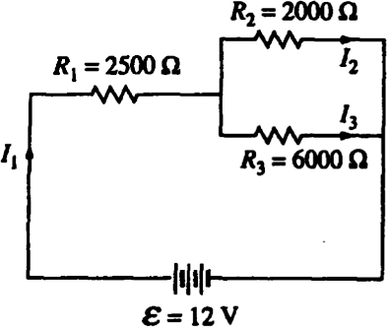
- What is the Current I₁?
  - 0.8 mA
  - 1 mA
  - 2 mA
  - 3 mA
  - 6 mA

- How do the currents I₁, I₂, and I₃ compare?
  - I₁ > I₂ > I₃
  - I₁ > I₃ > I₂
  - I₂ > I₁ > 1I₃
  - I₃ > I₁ > I₂
  - I₃ > I₂ > I₁

